Professional Commercial Storyboard:

I’m feeling generous! It’s a great day to give back to the community. Wait, what day is it? Anyway, the time has come for me to provide something of utility to the young storyboard artists out there. I have for you, for FREE DOWNLOAD (it’s on the internet, after all), my personal, made from scratch, professional commercial storyboarding template! Yes!
According to the file’s “created on” date, I crafted this template in 2009, when I began doing national commercials, and all my clients needed boards done in 16×9 format, for HD broadcast. Up until that point I was doing them in standard NTSC 4×3 aspect ratio.
So, here’s a preview, and here’s the official link to the image, which you can save to your hard drive!
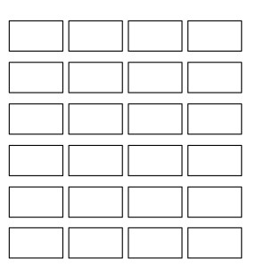
I’ll point out some details here. First off, this is not a definitive industry standard template (no such animal exists). It’s just the template I use for almost every project, and by nature of experience, I can testify it has worked out very well for me. But I by no means suggest that it is perfect for every storyboard. It is also not intended to be a “final” presentation storyboard- I use it to create my storyboards, and then after I’ve drawn them, the clients often give me their own template to transfer my frames into. So maybe think of this as a storyboarding workspace. It’s a bare bones grid of rectangles, in 16×9 ratio. Just add water. I mean, drawings.
The document itself is 3450 x 3600 pixels. That’s a fairly large image resolution but the frames themselves are only about 708 x 394, give or take. I’m aware that’s not HD resolution, and I’ll address that. If you’re looking for HD, scroll down to the bottom, where I have other templates available.
Lets talk a bit about why this template works well for me. As should be clear by now, I’m primarily a commercial storyboard artist, which means the stories I tell are about :30 long. The industry standard (if there is such a thing) number-of-frames-per-day for a commercial storyboard artist is about 18-21 frames, and that’s about right from what I’ve experienced.
So why use a 4×6 grid of 24 frames when 21 is the usual maximum? You see, a storyboard artist must provide more frames than the bare minimum, and sooner than the allotted time frame, because until the final versions are rendered and presented to client, one cannot know if the task is complete. For this reason, I always plan to overshoot the standard 21 frames per day standard, to be done sooner than the 8 hour typical allotment. Its like a “baker’s dozen” strategy- it’s not enough to only do what is asked, you must also provide alternate options, or at least be prepared for that possibility. Its very typical that when you present the final boards to client, they will, after seeing the work, realized that some things are missing, and that more work is to be done. If you had not accounted for this extra time, you’ll bust your deadline, and that’s the worst thing in the universe.
Blah blah blah. The point is, in the real world, you usually need about 21-24 frames in the final board, from which the director may edit to about 21 frames, and that’s why I made the template like this. 24 frames, all laid out nicely on one page, which is another advantage, and I’ll talk about that now.
In my experience, in order to truly see the story “flow” you need to be able to see all the frames at once. Or, at least in large batches. It’s easier for you as the artist to plot the continuity between frames and see what is needed to tell the story visually. And it’s easier for the client to evaluate for the same reason. I’m not just pulling this out of my butt. Take a look (below) at The Diz pouring over some boards with his target audience. He likes them all arranged in large batches so he can “read” them like a novel. It’s natural.
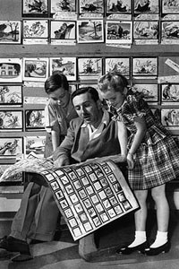
Also- its easier to draw! Because you keep the previous frames in your working memory as you draw the successive ones. You can easily reference an earlier images you’ve drawn, and of course that helps make sure your drawings are consistent.
That’s in contrast to what I’ve seen some of my commercial storyboarding colleagues do: the “one at a time” approach. They fire up photoshop and make individual files for each of the frames right off the bat, in isolation to one another. As a result, the boards are drawn without ease of consideration of what came previous and what comes next. They end up looking like “key frames,” which are not storyboards, but rather individual standalone storytelling moments used primarily for pitch purposes. It’s easy to confuse the two. Another weakness of this approach is that it unconsciously pushes the artist to treat the image as overly significant, and as a side effect, the image resolutions are made much too high, with far too much detail, which takes too long, it’s just no good. And the file sizes end up being huge, which is another problem, because often you have to be able to email these images to clients, or upload them to servers, and that takes up more time as well. Technology advances quickly, and these issues may fade with time, but for now, they are relevant. It’s happened often enough that I’ve emailed clients their storyboards only to find out at the 11th hour that my files never made it through because the attachment exceeded the maximum allowed by their email client.
So it’s advantageous that the frames on my template are about 700×400 pixels. It’s in the “Goldilocks” zone; not to big, not too small, just right. I’ve used this template on hundreds of projects and it’s really stood the test of time, so I recommend it highly.
And as by means of demonstration, here’s an example of how the template looks after a day of work: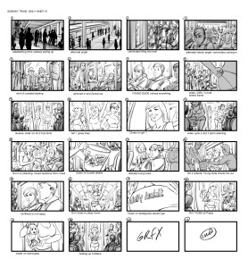

And, over the years, I’ve had to make other storyboarding templates, see below. I barely use them, but you may peruse and download them if you feel they could be of use. Enjoy!
